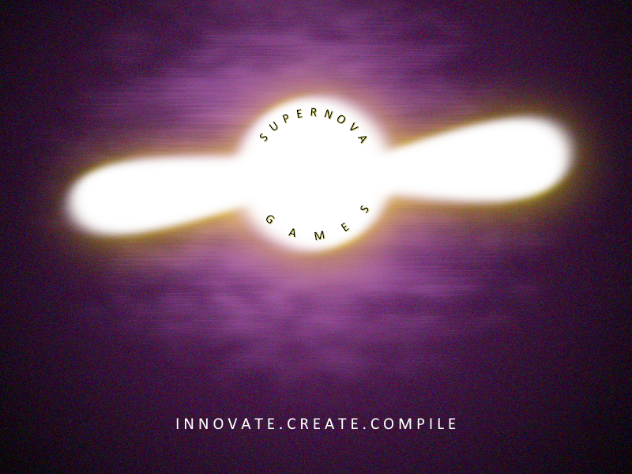

**SuperNova Games**

**‘InBetween’ Video Game Creation and Development**

**Request for Proposal**

**Version 1.0**

**Document History:**

| **Version** | **Date** | **Authors** | **Description** |
| --- | --- | --- | --- |
| 1.0 | 01/31/2025 | Uday Singh, Braydyn Proctor, Tavin Yorgason, Dax Collins, Zachary Haynie, Gabriel Roy, Liam Garner | Initial draft of the RFP document. |
| 1.1 | 2/3/2025 | Uday Singh, Braydyn Proctor, Tavin Yorgason, Dax Collins, Zachary Haynie, Gabriel Roy, Liam Garner | Revisions |

**Table of Contents:**

1.0 **Opportunity**

2.0 **Objectives and Goals**

3.0 **Similar Systems**

4.0 **Intended users and their basic interactions**

5.0 **Known interactions with other systems within or outside of the client organization**

6.0 **Known constraints to development**

7.0 **Project Schedule**

8.0 **Proposal Submission Guidelines**

9.0 **Key Dates**

10.0 **Glossary of Terms**

**1.0 Opportunity:**

With the booming sensation of roguelike/roguelites during the past several years, **SuperNova Games** has taken interest in capitalizing on the trend and wants to publish their own innovative title. Again these kinds of games are extremely popular, but they often tend to be either extremely difficult or easy meaning they only cater to certain kinds of players. SuperNova Games sees the opportunity to create a game that can cater to both casual and hardcore players alike, thus increasing the potential player base of our game. SuperNova Games is aiming to create a game that can become a worldwide sensation due to its accessibility, simplicity and narrative.

**2.0 Objectives and Goals:**

This request is looking for a talented team to bring **SuperNova Games** idea to life, In Between, a game about a warrior stuck in purgatory fighting his way for an escape to heaven, while avoiding danger that would drag him to hell.

**Key Requirements:**

**Tone:**

* Strong emphasis on atmosphere, you were a fierce warrior in life now trapped in purgatory fighting for eternal salvation from the depths of hell. The game should ensure the player knows what's at stake.
* Game assets should be a combination of either medieval, heavenly, demonic, or biblical themes/styles to help support the game's atmosphere.

**Player:**

* Player should have an XP system that allows them to obtain upgrades as they obtain XP.
* Player should be able to upgrade into a wide variety of different weapon classes.
* Player should be able to upgrade base stats (defense, speed etc…).

**Dungeon:**

* 5 main dungeon levels each with a unique theme.
* Procedurally generated using existing rooms (stitched together).

**Enemies**:

* Should be engaging.
* Killing enemies rewards the player XP.

**Scope:**

The scope of work for this project includes:

* **Game Design**: Create detailed game mechanics, levels, characters, and storyline.
* **Game Development**: Code and implement game features, mechanics, and ensure optimal performance across platforms.
* **Graphics and Sound Design**: Develop high-quality/ average-quality 2D models, animations, textures, sound effects, and music to create an immersive environment.
* **User Interface (UI)**: Design menus, controls, HUD, and ensure accessibility options are considered.
* **Quality Assurance (QA)**: Conduct extensive testing, debugging, and optimization to ensure the game meets performance standards.

**3.0 Similar Systems:**

There are 2 game titles and there aspects we are looking to have In Between take inspiration from:

**Binding of Isaac:**

* Dungeon room system

**Hades:**

* Combat style
* Overall gameplay
* Similar narrative (Zagreus escaping from Hell)

**4.0 Intended users and their basic interactions:**

The game will primarily target players aged 12-35, with a mix of casual and dedicated gamers. We envision the game appealing to fans of the roguelike/roguelite genre. Keyboard and mouse input guides the character through dungeons, earning upgrades and currency through room completion to fend off increasingly difficult foes and bosses until the final battle.

**5.0 Known interactions with other systems within or outside of the client organization:**

* Google Play
* Apple App Store
* Steam

**6.0 Known constraints to development:**

* Time for development
* Complexity of procedural generation code
* Creating the desired atmosphere

**7.0 Project Schedule:**

| Date | Description |
| --- | --- |
| 8 FEB 2025 | SA Demos |
| 11 FEB 2025 | Repository chosen and submitted |
| 21 FEB 2025 | Initial draft of the code should compile and run |
| 21 MARCH 2025 | Have two compile paths, production and testing, and run them both |
| 4 APRIL 2025 | Code should look like a game with missing features |
| 21 APRIL 2025 | Final Product Due |
| 1 MAY 2025 | Final Presentation |

**8.0 Proposal Submission Guidelines:**

To submit a proposal, please include the following documents:

1. **Proposal Document**: A detailed breakdown of your approach to the project, including timelines, deliverables, and pricing structure.
2. **Portfolio/Case Studies**: Examples of previous work, particularly related to game development.
3. **Team Composition**: Details of the team members, including their roles and experience.
4. **Project Plan**: A Gantt chart or other scheduling tools to outline the development timeline and milestones.

Please submit all proposals by **uploading them on the Class Project GitHub repository**.

**9.0 Key Dates:**

Proposals must be submitted by 2359 PST, 8 FEB 2025. A decision for the winner will be made and released by 10 FEB 2025.

**10.0 Glossary of Terms:**

* **UI/UX**: User Interface and User Experience design that focuses on optimizing the game’s interface for ease of use.
* **Roguelike:** A genre of game where upon death the player starts the game over from the beginning starting completely fresh.
* **Roguelite:** Similar to the roguelike genre except that the player may keep some items between deaths (could currency, upgrades etc…).